How to get into Google Classrooms

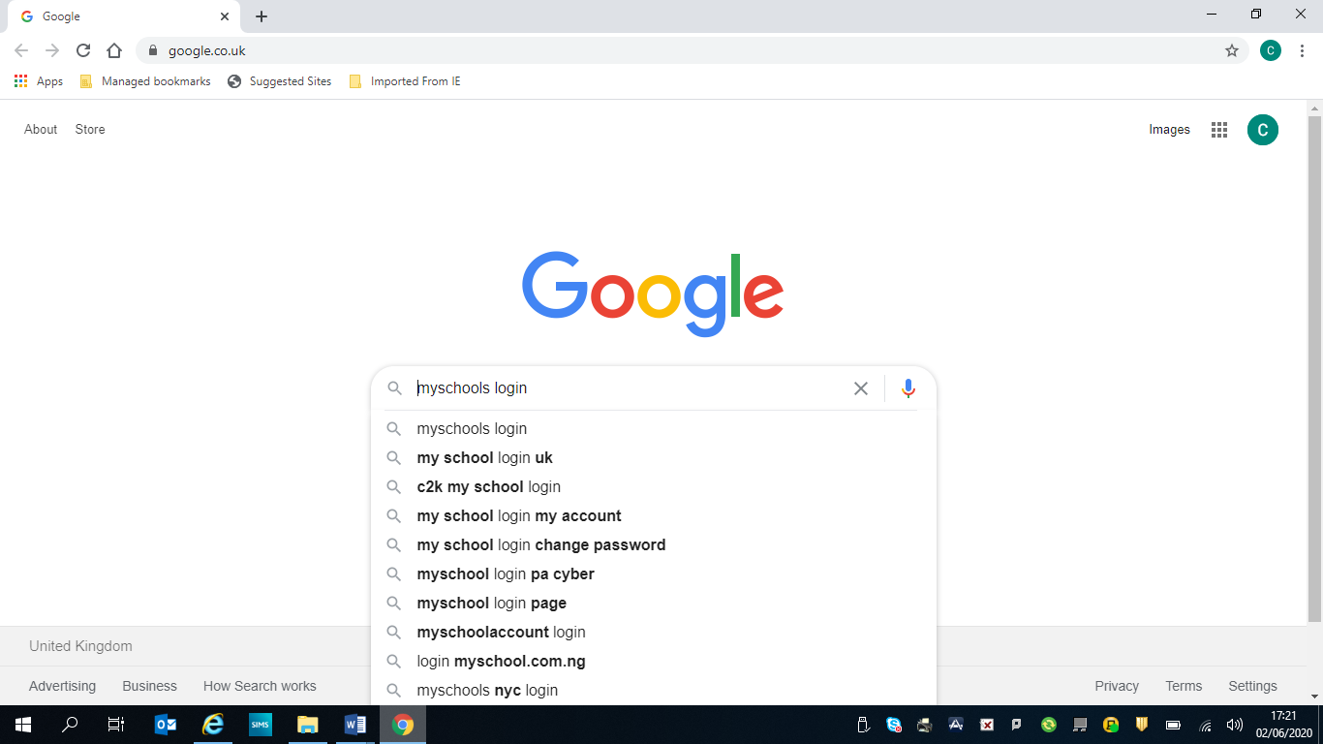
Step 1 – In safari or Google search for my school login

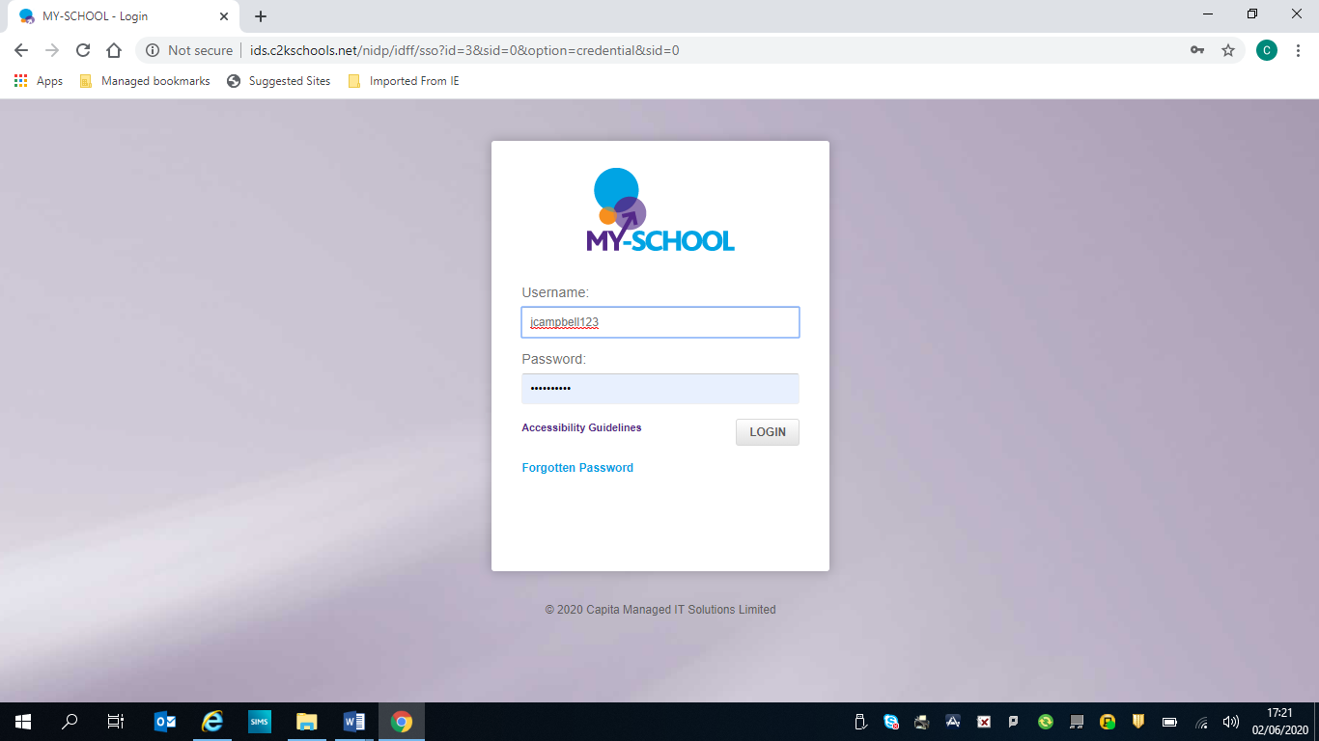
Step 2 – Enter your child’s username and password. They should remember this. If not contact your child’s class teacher via your email link.
This will bring you to your child’s homepage screen.

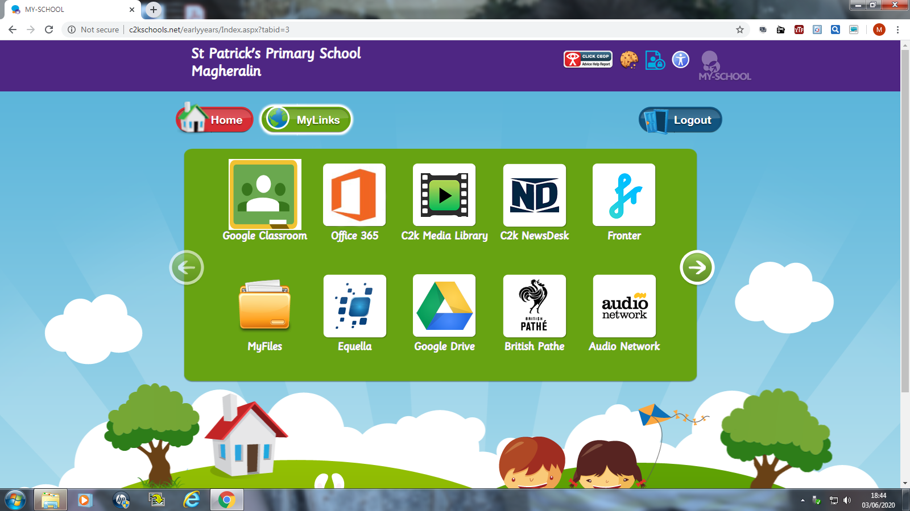
Step 3 –In your homepage click on My Links then click into Google classroom

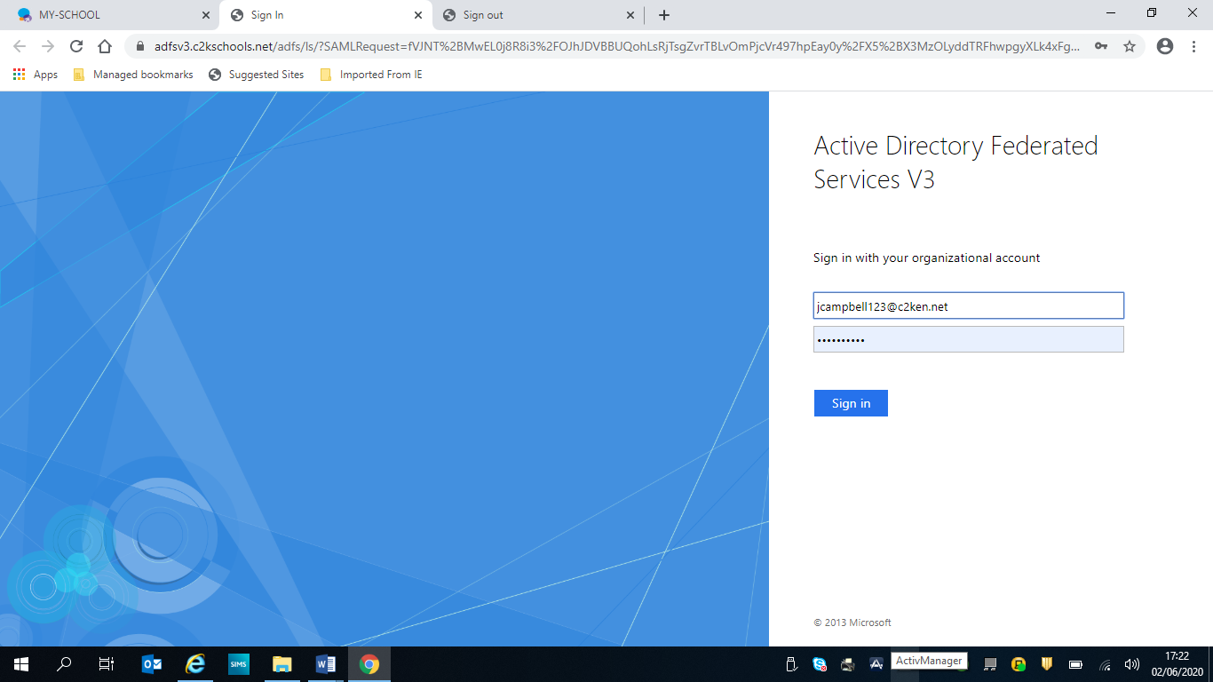
Step 4 –The first time you enter google classroom, you may get this page.
Enter your child’s username eg jbloggs123 (and without spaces add on @c2ken.net)
jbloggs123@c2ken.net
Then enter their normal password.

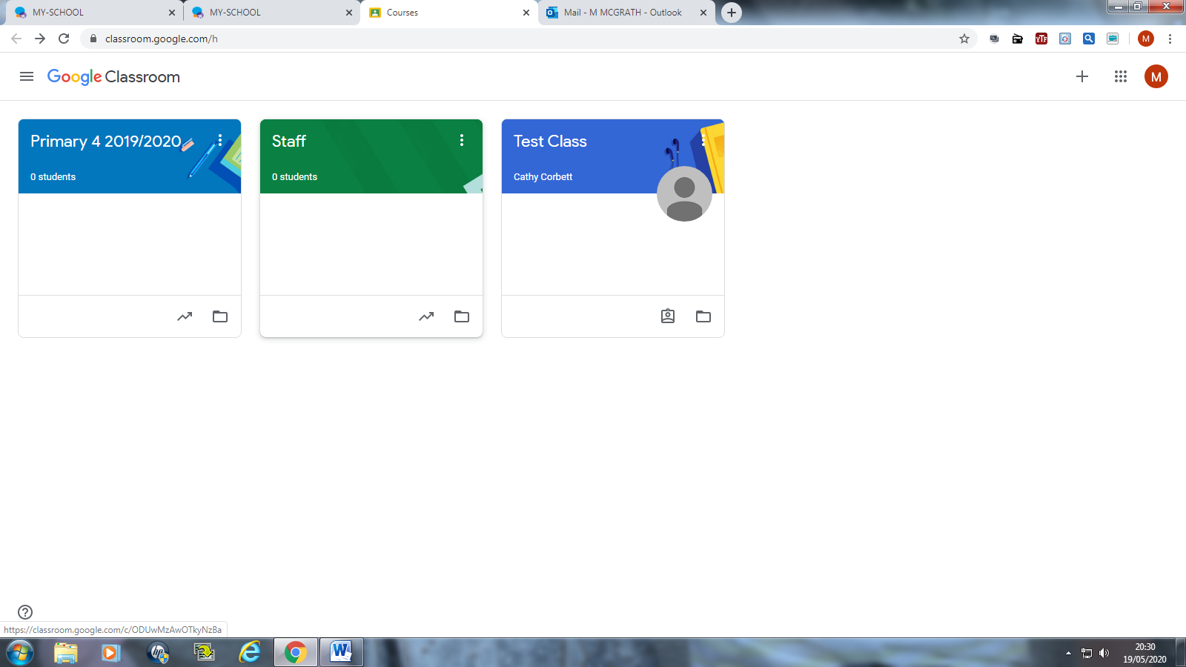
Step 5 – click on this cross. It will ask you to join the class

At this point you will not have any classes like these until your join your own class.

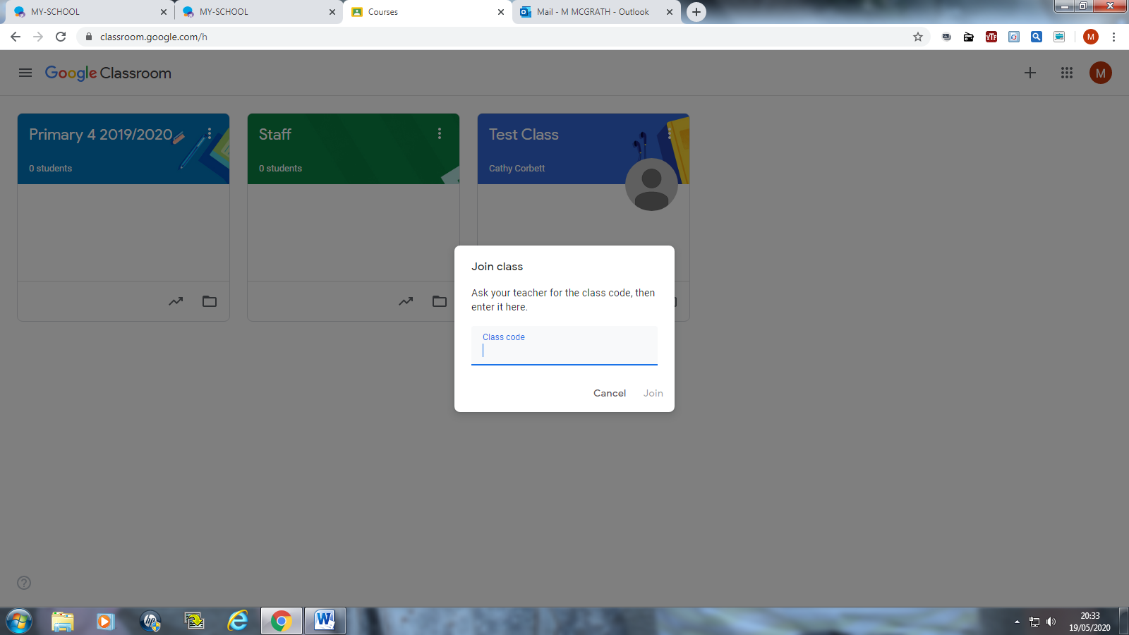
Step 6 – enter the class code - Class teachers will text this to their parents

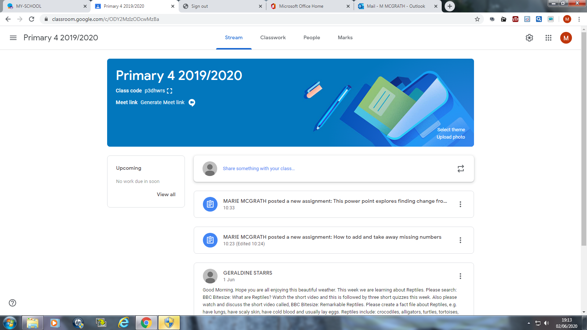
Step 7 – you should see your child’s class and information or work that has been added by the class teacher.

