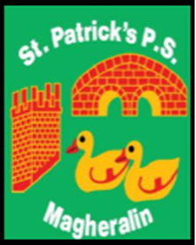

ST. PATRICK’S PRIMARY SCHOOL
12 Ballymacbredan Road, Magheralin, Craigavon. BT67 OQU
Tel no – 028 3834 1400 Fax no – 028 3834 7376
Email: info@stpatricks.magheralin.ni.sch.uk
Principal: Mrs. M. McGrath. BA(QTS), PQHSH, DipPD.
‘Together we learn, together we grow, developing our future, wherever we go!’

18th August 2020

Dear Parents

I am now able to clarify the school’s position on Breakfast and Afterschool clubs.

Thank you to those parents who indicated their needs re these clubs from September 2020.

At this point we are still unable to offer Afterschool clubs due to the perceived higher risk within each club.

We do feel however that we can offer Breakfast Club from 8am and Drop Off Club from 8:30am each morning.

The children in each of these clubs will be in different designated rooms in school. The children in Breakfast Club and Drop Off Club will also be kept in their class bubbles at tables that will be assigned to them.

At this point we will only offer the club to those families who indicated their need for Breakfast/Drop Off Club in July 2020. These parents will receive a school text. Please inform us at your earliest opportunity if you do not wish your child to attend.

Anyone else wishing to access the clubs must give the school office 1 full weeks’ notice of your intention to use this club on a particular morning. This will allow us time to review the numbers in each bubble to ascertain if we can meet your request. Please ensure that you have received an email confirming your child’s place in the breakfast/drop off club before you send your child that morning.

We can not allow any child to attend the clubs if they have not been booked in correctly.

Breakfast and Drop Off club will be in operation from Tuesday 1st September.

The position surrounding all Clubs will be reviewed at the end of October.

We appreciate your understanding and cooperation to date. We all look very much forward to welcoming your children back to school.

Yours sincerely

Mrs M. McGrath
Principal

