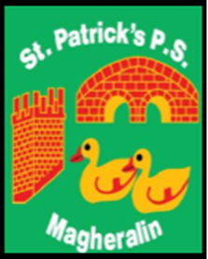

ST. PATRICK’S PRIMARY SCHOOL
12 Ballymacbredan Road, Magheralin, Craigavon. BT67 OQU
Tel no – 028 3834 1400 Fax no – 028 3834 7376
Email: info@stpatricks.magheralin.ni.sch.uk
Principal: Mrs. M. McGrath. BA(QTS), PQHSH, DipPD.
‘Together we learn, together we grow, developing our future, wherever we go!’

15th September 2020

REF: Schools Savings Scheme

Dear Parent
Lurgan Credit Union have informed school they have made the decision to postpone recommencing their ‘Schools Savings Scheme’ due to the COVID-19 outbreak.
They wish to state that their office, in Lurgan, is still open for children who wish to continue saving.
In addition, parents can set up regular payments via direct debit. Forms are available from their website or office. Furthermore, debit card payments can now also be taken over the phone.
If you have any queries, do not hesitate to contact Lurgan Credit Union office on 028 3832 5016 or manager@lurgancu.com

Yours sincerely
School Office

