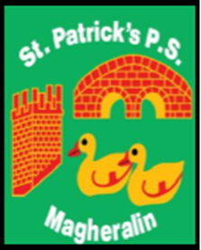

ST. PATRICK’S PRIMARY SCHOOL
12 Ballymacbredan Road, Magheralin, Craigavon. BT67 OQU
Tel no – 028 3834 1400 Fax no – 028 3834 7376
Email: info@stpatricks.magheralin.ni.sch.uk
Principal: Mrs. M. McGrath. BA(QTS), PQHSH, DipPD.
‘Together we learn, together we grow, developing our future, wherever we go!’

14th October 2020
Dear Parents
Today we have been advised by the Northern Ireland Executive Office, that schools in Northern Ireland will close from Monday 19th October and remain closed through the already planned for Halloween break.
The purpose of this break is to reduce the increasing spread of the Covid-19 virus.

‘The half term holiday break for schools and colleges will be extended to a two-week break to run from 19th to 30th October.’
(The Executive Office – 14th October 2020)

We have been advised by EA that during this two-week extended mid-term break there will be NO requirement for Home School Learning.
We have established very good routines in place with our children with reference to handwashing, tissue use and bubbling in our school and in all of our homes. It is with these effective practices in place that it is hoped that the announced extended break, will curb any further increase and spread of the virus and allow us all to safely return to school on Monday 2nd November.
Should the closure be extended, we have plans in place to facilitate remote learning, using a blend of paper and online approaches to support learning.
Our first priority is and always will be the health, safety and well-being of our pupils and their families, our staff and the wider community. By remaining vigilant at all times we will keep each other safe.

May we continue to pray to God and St Patrick for the continued good health and safety of everyone in our school community.
Yours sincerely,
Mrs M McGrath
Principal

