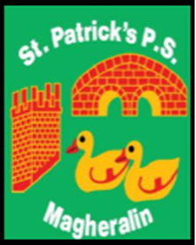

ST. PATRICK’S PRIMARY SCHOOL
12 Ballymacbredan Road, Magheralin, Craigavon. BT67 OQU
Tel no – 028 3834 1400 Fax no – 028 3834 7376
Email: info@stpatricks.magheralin.ni.sch.uk
Principal: Mrs. M. McGrath. BA(QTS), PQHSH, DipPD.
‘Together we learn, together we grow, developing our future, wherever we go!’

22nd December 2020

Dear Parents

As we reach the Christmas holiday break, I would like to send my gratitude and appreciation to you all as parents for the support you have given to school, in what has been a very challenging time for everyone.

School life has changed in many ways and we are operating within a new normal. We thank you for your co-operation as we have implemented required changes, that are in place to keep everyone involved in our school, safe.

I also take this opportunity to pay tribute to the wonderful staff in our school, who have worked tirelessly to ensure that your children have a safe and welcoming learning environment, where they can continue to progress in their educational journey. Their support and pastoral care for your children and their welfare has been excellent.

Finally, our pupils, they have been amazing at all times! They have always worked very hard, giving of their best efforts and manners and deserve to have a wonderful Christmas break with their families. I’m sure that Santa will be very good to them!

I wish you all a very peaceful, joyous and safe Christmas holiday and look forward to seeing you all safe and well in January.

Best Wishes

Marie McGrath
Principal

