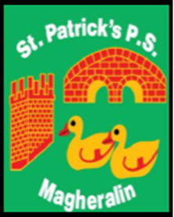

ST. PATRICK’S PRIMARY SCHOOL
12 Ballymacbredan Road, Magheralin, Craigavon. BT67 OQU
Tel no – 028 3834 1400 Fax no – 028 3834 7376
Email: info@stpatricks.magheralin.ni.sch.uk
Principal: Mrs. M. McGrath. BA(QTS), PQHSH, DipPD.
‘Together we learn, together we grow, developing our future, wherever we go!’

7th January 2021

Dear Parents

In light of the announced period of school closure we will continue to support and accommodate our parents who are Key workers and are critical in the ongoing fight against Covid-19 in our society. As we have been doing from Monday 4th January, we will continue to provide ‘supervised’ learning for children from 9am to the end of their normal school day, Monday to Friday. This will continue until we can return to face to face teaching.

If you are an identified Key worker please contact us by 3:00pm Friday 8th January, via the school email info@stpatricks.magheralin.ni.sch.uk and we will endeavour to support you in your important role.

Please note that this ‘supervision’ is only aimed at children of parents who are key workers. If possible, alternative childcare arrangements should be sought before sending your child/ren to school.

Kind Regards
Mrs M. McGrath

