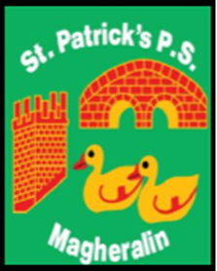

ST. PATRICK’S PRIMARY SCHOOL
12 Ballymacbredan Road, Magheralin, Craigavon. BT67 OQU
Tel no – 028 3834 1400 Fax no – 028 3834 7376
Email: info@stpatricks.magheralin.ni.sch.uk
Principal: Mrs. M. McGrath. BA(QTS), PQHSH, DipPD.
‘Together we learn, together we grow, developing our future, wherever we go!’

9th February 2021

Dear Parents

Re: Half-term break – 15th – 19th February

School will be closed to all pupils next week for our half-term break. There will be no supervised learning.

On behalf of the whole school team, I wish to thank all our parents for your continued support throughout the term and our children for working so hard. It will be a very well-deserved break!

Teachers have prepared home learning packs for your children for the first week after half-term, i.e., the week beginning Monday 22nd February.

Primary 1 to Primary 7 Home Learning Packs can be collected this Friday afternoon between 2 and 3pm.

May we all continue to pray for the continued health and safety of all in our school community.

Yours sincerely

Mrs McGrath
Principal

