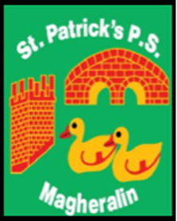

ST. PATRICK’S PRIMARY SCHOOL
12 Ballymacbredan Road, Magheralin, Craigavon. BT67 OQU
Tel no – 028 3834 1400 Fax no – 028 3834 7376
Email: info@stpatricks.magheralin.ni.sch.uk
Principal: Mrs. M. McGrath. BA(QTS), PQHSH, DipPD.
‘Together we learn, together we grow, developing our future, wherever we go!’

11th March 2021

Dear Parent
Our Friends of St Patrick’s Group have been working hard to create a St Patrick’s Day fun pack for every child in school. The packs contain some chocolate coins, a chocolate bar, a bag of crisps, some colouring pages, some fun quiz/word search pages and arts and craft activities with coloured paper, pipe cleaners, beads and stickers. There is an envelope inside each pack containing the small parts, so we ask parents to look carefully at the contents of each pack.
On behalf of everyone in St Patrick’s, I extend our appreciation to the Friends of Group for their efforts in getting these packs together. We also extend our gratitude to Centra, Magheralin and Tesco, Lurgan for their kind contributions.
The packs have been kept in school for a period of quarantine this week and will be given out to children in the following ways. Our children will be able to enjoy some lovely craftwork on St Patrick’s Day.

- Rec to P3 can get their packs home from school on Friday 12th and they can take home for any older siblings P5 to P7

- P4 can get their packs with their home learning packs on Friday,12th.

- Any P5 to P7 who attends supervision can get their pack on Friday, 12th.

- All other P5 to P7 children up (who don't have siblings and are not in supervision) can pick their pack up from school on Monday 15th and Tuesday 16th between 2:30 and 3pm each day.

Yours sincerely
Mrs M McGrath
Principal

