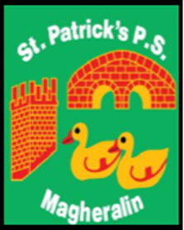

ST. PATRICK’S PRIMARY SCHOOL
12 Ballymacbredan Road, Magheralin, Craigavon. BT67 OQU
Tel no – 028 3834 1400 Fax no – 028 3834 7376
Email: info@stpatricks.magheralin.ni.sch.uk
Principal: Mrs. M. McGrath. BA(QTS), PQHSH, DipPD.
‘Together we learn, together we grow, developing our future, wherever we go!’

15th March 2021

Dear Parents

The Minister for Education has confirmed that pupils in Reception and Primary One, Primary Two and Primary Three classes will continue to be provided full-time face-to-face teaching until the school’s planned Easter holidays. The pupils in the above year groups will therefore continue to be in school until Tuesday 30th March at 2pm and will not receive remote learning.

All other pupils in Primary Four to Primary Seven will continue to receive remote learning until further notice is provided by the Department of Education.

We will continue to update you as and when further decisions are made by the Department of Education.

Yours sincerely

Mrs Marie McGrath
Principal

