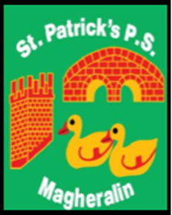

ST. PATRICK’S PRIMARY SCHOOL
12 Ballymacbredan Road, Magheralin, Craigavon. BT67 OQU
Tel no – 028 3834 1400 Fax no – 028 3834 7376
Email: info@stpatricks.magheralin.ni.sch.uk
Principal: Mrs. M. McGrath. BA(QTS), PQHSH, DipPD.
‘Together we learn, together we grow, developing our future, wherever we go!’

29th March 2021

Dear Parent

Breakfast Club & After School Club

In a letter dated 26th March 2021, the Department of Education has confirmed that school managed breakfast clubs and after school clubs are to remain paused until advised otherwise. We are therefore unable to re-open Breakfast and Afterschool clubs at this point.

The Department of Education will inform schools when there is any change to this position, and we will inform you accordingly.

Yours sincerely
Mrs McGrath
Principal

