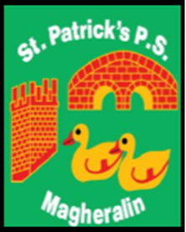

ST. PATRICK’S PRIMARY SCHOOL
12 Ballymacbredan Road, Magheralin, Craigavon. BT67 OQU
Tel no – 028 3834 1400 Fax no – 028 3834 7376
Email: info@stpatricks.magheralin.ni.sch.uk
Principal: Mrs. M. McGrath. BA(QTS), PQHSH, DipPD.
‘Together we learn, together we grow, developing our future, wherever we go!’

28th May 2021

Dear Parent
As you may be aware, this year, we were sadly bereaved of one of our parents, Ms Laura Gracey. May she Rest in Eternal Peace. Prior to Christmas, Ms Gracey had asked if we could support a fundraising initiative throughout this academic year. In support of this request we are organising a sponsored walk to raise funds for Cancer Fund for Children.

Daisy Lodge in Newcastle county Down, is a therapeutic centre designed to support families affected by cancer. Their logo uses an image of a beautiful daisy. With this in mind we would like the children to wear daisies, if they can, and/or wear bright yellow clothing for the walk.

We aim to hold the sponsored walk in St Michael’s GFC grounds on Wednesday 16th June during school hours. We would like the children from Reception to Primary 4 to walk 2Km and the children in Primary 5 to Primary 7 to walk 5Km.

This year, with current restrictions still in place we are aware that children may not be able to ask extended family members and friends to sponsor their walk. It is with this in mind that we therefore kindly ask for donations. You may put donations into a sealed envelope or you may make a donation via Eduspot. Every and any donation is most welcome. We would ask that all donations are received to school by Friday 18th June.

Laura and her family continue to be in our thoughts and prayers at this time.

With sincere thanks and appreciation in advance of your support

Mrs McGrath
Principal

