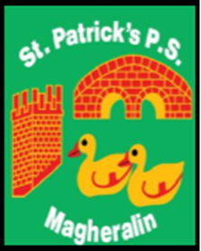

ST. PATRICK’S PRIMARY SCHOOL
12 Ballymacbredan Road, Magheralin, Craigavon. BT67 OQU
Tel no – 028 3834 1400 Fax no – 028 3834 7376
Email: info@stpatricks.magheralin.ni.sch.uk
Principal: Mrs. M. McGrath. BA(QTS), PQHSH, DipPD.
‘Together we learn, together we grow, developing our future, wherever we go!’

8th June 2021
Dear Parent
School Information Sheet
- School Closure Dates for 2021/2022

- Wednesday 1st September – School re-opens for the new school year!
- Monday 25th October to Friday 29th October -School closed - Halloween break and Staff
Development
- Thursday 23rd December – Tuesday 4th January 2022 -School Closed - Christmas
break and Staff Development
- Monday 14th – Friday 18th February - School Closed - Half Term
- Thursday 17th March and Friday 18th March - School Closed - St Patrick’s celebration and
Staff Development
- Thursday 14th April – Friday 22nd April - School Closed – Easter break
- May 2nd - School closed - Bank Holiday
- Wednesday 1st June to Friday 3rd June– School closed – Bank Holiday and
Staff Development
- June 30th - School closes for the academic year.
Please note that you should not take family holidays during term times.

- Below you shall find an up-dated list of our classes for next year.
- Reception/ Primary 1 - Miss Oliver
- Primary 2/3 - Mrs Canavan (4 days) / Mrs Starrs (1 day)
- Primary 4/5 - Mrs Corbett
- Primary 6 - Mrs Starrs (2 days) and Mrs McGrath (3 days)
- Primary 7 - Mrs Magennis

Yours sincerely
Mrs. McGrath

