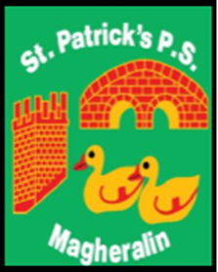

ST. PATRICK’S PRIMARY SCHOOL
12 Ballymacbredan Road, Magheralin, Craigavon. BT67 OQU
Tel no – 028 3834 1400 Fax no – 028 3834 7376
Email: info@stpatricks.magheralin.ni.sch.uk
Principal: Mrs. M. McGrath. BA(QTS), PQHSH, DipPD.
‘Together we learn, together we grow, developing our future, wherever we go!’

29th June 2021

Dear Parent/Guardian

In the past 16 months or so we have seen huge changes in our society as a whole, with so many restrictions in place changing the various ways that we work and the activities we take for granted, due to COVID-19. Currently we are seeing cautious moves forward to regain some normality, which we hope can continue into the next academic year.
It is with continued caution, but also hope in an improving future, that we can try to plan ahead.
Next year we hope to reach out to our parents and grandparents to ask for their time and skills in a voluntary capacity.
We have many people in our community that have gardening, art, sewing, plumbing, joinery and many other skills and talents that we would just love to have the support of in school, to help staff with various projects or school events and trips. There are many fields of industry that our children would love to learn about! We’d love to hear from you.
Our Friends of St Patrick’s group would also like to reach out to all parents who may be able and are willing to join their group. They would also love to hear from you and will be in touch early in the new school year.
If you feel that you would be able to volunteer your help, skills or talents in any way described above, please let us know by emailing the school office as above.
We will reach out again in September to ask for your help, providing that restrictions will allow us to do so.

Kind Regards
Mrs M McGrath
Principal

