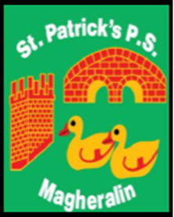

ST. PATRICK’S PRIMARY SCHOOL
12 Ballymacbredan Road, Magheralin, Craigavon. BT67 OQU
Tel no – 028 3834 1400 Fax no – 028 3834 7376
Email: info@stpatricks.magheralin.ni.sch.uk
Principal: Mrs. M. McGrath. BA(QTS), PQHSH, DipPD.
‘Together we learn, together we grow, developing our future, wherever we go!’

September 2021

Dear Parent,

As we have in the recent past, we respectfully ask that our parents make a voluntary contribution to our School Fund, of £15 per child per year, to a maximum of £30 per family per year. This cost can be spread out over the three school terms, or paid as a one off payment.
Contributions received will be spent on termly requirements, which will be used to enhance your child’s learning environment and help purchase school resources.
This year we are making investment in our Literacy resource and all contributions will be hugely appreciated.

We will also continue with our texting service and online money service to parents. To support us in the cost of this very valuable and convenient service, we ask each family to contribute the sum of £15:00. This payment can be made using our online service. It can be made as £5 per term or as one payment.

A text has been sent to all parents today. Can you please inform the office if you did not receive a text, as this will ensure that all of our contact details are correct.

All schools are facing very tough economic times ahead and are now, or already have been, requesting support from parents. We aim to always keep this to a minimum.

These payments can be made using our online service.

Yours sincerely,

Mrs. McGrath
Principal
On behalf of the Board of Governors

