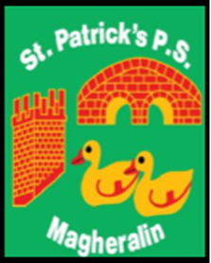

ST. PATRICK’S PRIMARY SCHOOL
12 Ballymacbredan Road, Magheralin, Craigavon. BT67 OQU
Tel no – 028 3834 1400 Fax no – 028 3834 7376
Email: info@stpatricks.magheralin.ni.sch.uk
Principal: Mrs. M. McGrath. BA(QTS), PQHSH, DipPD.
‘Together we learn, together we grow, developing our future, wherever we go!’

15th December 2021

Dear Parent

I have been approached again this year by the Church of Ireland in Magheralin, with a generous offer of support for families within our school community, who are or may be in some need, at this difficult time. This support is in the form of a small food hamper.

If you would like to receive a hamper, or are aware of another family who may appreciate this support, please contact me via email. Any request for a Hamper will be treated in the strictest of confidence.

Please reply directly to my email mmcgrath481@c2kni.net and we will arrange for you to collect your hamper, at a time which is suitable to you.

Your sincerely

Mrs M McGrath
Principal

