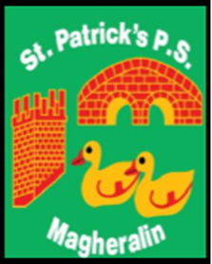

ST. PATRICK’S PRIMARY SCHOOL
12 Ballymacbredan Road, Magheralin, Craigavon. BT67 OQU
Tel no – 028 3834 1400 Fax no – 028 3834 7376
Email: info@stpatricks.magheralin.ni.sch.uk
Principal: Mrs. M. McGrath. BA(QTS), PQHSH, DipPD.
‘Together we learn, together we grow, developing our future, wherever we go!’

21st December 2021

Dear Parent / Guardian

As we approach the Christmas holiday, I would like to offer my gratitude and appreciation to you all as parents for the support you have given to school, in what has been another very challenging time for everyone.

I thank you for your co-operation as we have continued to operate in a way that aims to keep everyone involved in our school, safe.

The staff in our school, have worked tirelessly to ensure that your children have a safe, happy and welcoming learning environment. Their support and dedication to all of the children, and to each other as a team in St Patrick’s, is to be greatly commended.

Finally, our pupils, they have been superb at all times! They deserve to have a wonderful Christmas break with their families. I am sure that Santa will be very good to them!

School aims to reopen on Thursday 6th January. Breakfast, Drop off and Afterschool clubs will reopen on this date also.

On behalf of everyone at St. Patrick’s, I wish you a very peaceful, joyous and safe Christmas holiday and look forward to seeing you all, safe and well, in January 2022.

Best Wishes

Marie McGrath
Principal

