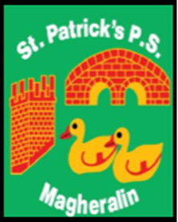

ST. PATRICK’S PRIMARY SCHOOL
12 Ballymacbredan Road, Magheralin, Craigavon. BT67 OQU
Tel no – 028 3834 1400 Fax no – 028 3834 7376
Email: info@stpatricks.magheralin.ni.sch.uk
Principal: Mrs. M. McGrath. BA(QTS), PQHSH, DipPD.
‘Together we learn, together we grow, developing our future, wherever we go!’

10th May 2022

Dear Parents

School Dinner payments
Principal

