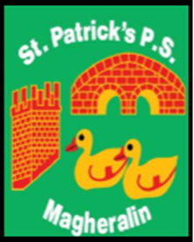
23

ST. PATRICK’S PRIMARY SCHOOL
12 Ballymacbredan Road, Magheralin, Craigavon. BT67 OQU
Tel no – 028 3834 1400 Fax no – 028 3834 7376
Email: info@stpatricks.magheralin.ni.sch.uk
Principal: Mrs. M. McGrath. BA(QTS), PQHSH, DipPD.
‘Together we learn, together we grow, developing our future, wherever we go!’

23rd May 2022

Dear Parent / Guardian

Magheralin Community Association has obtained a cross community grant in relation to the upcoming Platinum Jubilee, from ABC Council. The funding gained has been shared among the local community primary schools.

On Tuesday 31st May, we intend to hold a ‘Tea Party’ in school. We are hoping that this is a fun day with face painting, outside games, a visit from C&J Animals and some cake and buns!

We are asking the school kitchens to provide us with a ‘Happy Meal’ style dinner, as they did at Christmas time. We would hope that as many children as possible would take dinner on this day and we hope, weather permitting, to eat outside.

We ask that you book this meal as soon as possible to allow school kitchens to be prepared in advance.

Children may wear their own clothes and bring a picnic blanket to school on the day.

Please advise your child’s class teacher, if you do not wish to have your child’s face painted.

Yours sincerely

Mrs M. McGrath
Principal

