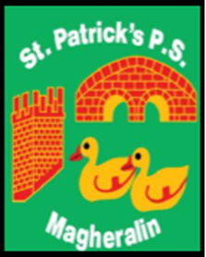

ST. PATRICK’S PRIMARY SCHOOL
12 Ballymacbredan Road, Magheralin, Craigavon. BT67 OQU
Tel no – 028 3834 1400 Fax no – 028 3834 7376
Email: info@stpatricks.magheralin.ni.sch.uk
Principal: Mrs. M. McGrath. BA(QTS), PQHSH, DipPD.
‘Together we learn, together we grow, developing our future, wherever we go!’

1st June 2022

Dear Parent

Free School Meals/School Uniform/Physical Education Uniform Allowance 2022-23

Parents/guardians who are currently in receipt of support for the 2021/22 school year will receive a letter highlighting the need to apply for the 2022/23 school year and the process to do so. The EA encourages all potential applicants to apply for the support available, before 31 July to ensure all is in place for the new school year in September 2022.

All parents/guardians (including new applicants) will be able to apply online from week commencing 6 June 2022 via the EA website – scroll down and click Free School Meals / Uniform Grants

It is important for all applicants to read and understand what supporting documentation is required for their application. Information on this can be found on the EA website.

Special Diet
Parents/Guardians whose child has a Statement of Special Educational Needs (Stage 5) and requires a special diet should contact the Meals and Uniform Section for a paper application form if they wish to apply under the special diet criterion.

Free School Meals / Uniform Allowance Helpdesk
The Free Schools Meals and Uniform Allowance Helpdesk is operated by staff across the EA Free School Meals/Uniform Allowance service. It is available to assist parents and guardians who may have any queries. The Helpdesk operates Monday – Friday from 9am to 4.30pm and can be contacted via email: mealsanduniform@eani.org.uk. The telephone number which should be used for all enquiries is 028 9041 8044.

