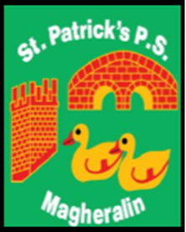

ST. PATRICK’S PRIMARY SCHOOL
12 Ballymacbredan Road, Magheralin, Craigavon. BT67 OQU
Tel no – 028 3834 1400 Fax no – 028 3834 7376
Email: info@stpatricks.magheralin.ni.sch.uk
Principal: Mrs. M. McGrath. BA(QTS), PQHSH, DipPD.
‘Together we learn, together we grow, developing our future, wherever we go!’

6th September 2022

Dear Parent

School Dinner bookings and payments

As we begin our new school year, we respectfully ask that all dinners are booked and paid for on Eduspot in advance. The dinner menu has been placed on our school website, under Info for Parents – Dinner Menus

If you need to cancel a planned dinner for any reason, please email the school office before 9.15am on the day the dinner has been booked otherwise it will be ordered and you will be charged.

If a child is absent from school due to sickness, the dinner booking will be cancelled and a refund credited to your Eduspot account.

Our accounts must reconcile with EA School Meals Service.

We thank you in advance for your co-operation.

Yours sincerely
School Office

