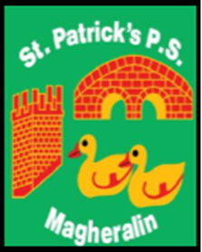

ST. PATRICK’S PRIMARY SCHOOL
12 Ballymacbredan Road, Magheralin, Craigavon. BT67 OQU
Tel no – 028 3834 1400 Fax no – 028 3834 7376
Email: info@stpatricks.magheralin.ni.sch.uk
Principal: Mrs. M. McGrath. BA(QTS), PQHSH, DipPD.
‘Together we learn, together we grow, developing our future, wherever we go!’

27th October 2022

Dear Parent/Guardian

Beginning Wednesday 9th November, Dr. Blathnaid Carlin and Gerard Scullion, parents of two children in our school, are to support us in offering a 6 week course in afterschool called ‘Minds in Motion’ to children in Primary 1 to Primary 3 classes. The club will run from 2pm to 3pm each Wednesday afternoon.
The cost of the club will be £3.50 per week. If you are interested in your child attending, please complete payment via eduspot by booking into 2-3pm option 9, each Wednesday afternoon.
Details of the content of the course can be found at the end of this letter.

Yours sincerely
Mrs McGrath
MINDS IN MOTION

6 week course tailored for young minds with 4 main objectives:

-Understanding and normalising big emotions.
It's ok to feel sad.

-Self love and kindness to ourselves and others.

-How to keep our hearts and minds healthy:
activity and diet.

-Toolbox for life: how to boost our happy hormones and when to ask for help.

Nurturing our children’s mental health from a young age is so important. We hope to help teach the children about regulating their emotions in a healthy way and arm them with the tools to overcome adversity in the future.

