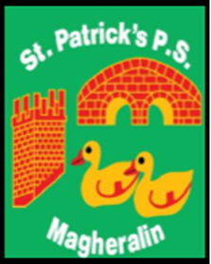

ST. PATRICK’S PRIMARY SCHOOL
12 Ballymacbredan Road, Magheralin, Craigavon. BT67 OQU
Tel no – 028 3834 1400 Fax no – 028 3834 7376
Email: info@stpatricks.magheralin.ni.sch.uk
Principal: Mrs. M. McGrath. BA(QTS), PQHSH, DipPD.
‘Together we learn, together we grow, developing our future, wherever we go!’

November 2022

Dear Parent,
Monday 14th November marks the beginning of Anti-Bullying week. Throughout the week the children will discuss what bullying means in Assembly and in their classes and participate in being a buddy with children from another class. The theme this year is ‘Reach Out’.
To mark the beginning of this very important week, we will participate in
ODD Socks Day on Monday 14th November.
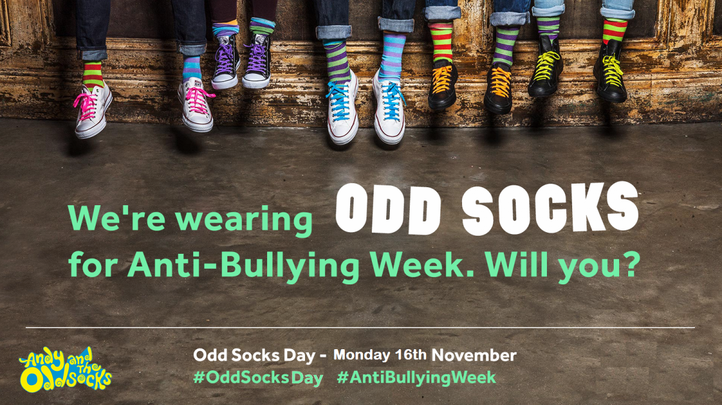

Each child, and adult too, can wear odd socks to school. Odd socks day is designed to be fun! ‘It is an opportunity for children to express themselves and celebrate their uniqueness.’

Yours sincerely,
Mrs. McGrath
Principal

