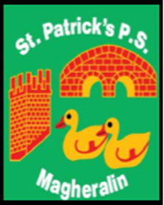

ST. PATRICK’S PRIMARY SCHOOL
12 Ballymacbredan Road, Magheralin, Craigavon. BT67 OQU
Tel no – 028 3834 1400 Fax no – 028 3834 7376
Email: info@stpatricks.magheralin.ni.sch.uk
Principal: Mrs. M. McGrath. BA(QTS), PQHSH, DipPD.
‘Together we learn, together we grow, developing our future, wherever we go!’

15th December 2022

Dear Parent / Guardian,

We have been informed that another child who attends St Patrick’s Primary School has been diagnosed with scarlet fever. The Public Health Agency have advised that because of increased rates Group A streptococcus in the community compared to what is usually seen at this time of year, that it is not unexpected that schools and early years settings will see cases.

The Public Health Agency has provided the enclosed information leaflet for parents and guardians. I would encourage to read it as it contains useful information about the scarlet fever and other infections caused by Group A streptococcus.

If your child is unwell, they should not attend school or early years settings.

If your child is diagnosed with scarlet fever they should stay at home and not attend school or early years settings for at least 24 hours after starting the antibiotic treatment, to avoid spreading the infection.

Further information about scarlet fever is available on the PHA website: https://www.publichealth.hscni.net/news/scarlet-fever and http://pha.site/scarlet-fever-2022 and also on NI Direct https://www.nidirect.gov.uk/conditions/scarlet-fever

Yours sincerely
Mrs McGrath
Principal

