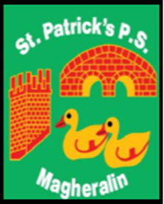

ST. PATRICK’S PRIMARY SCHOOL
12 Ballymacbredan Road, Magheralin, Craigavon. BT67 OQU
Tel no – 028 3834 1400 Fax no – 028 3834 7376
Email: info@stpatricks.magheralin.ni.sch.uk
Principal: Mrs. M. McGrath. BA(QTS), PQHSH, PGDip.
‘Together we learn, together we grow, developing our future, wherever we go!’

30th June 2023

Dear Parent / Guardian

As we have come to the end of another school year, I would like to express my sincere appreciation for your support to the staff and children of our school. Together as a community, our children have felt the support they have needed, to work as hard as they have to make progress in all areas of school life. Their academic, physical, social and emotional needs have been a priority for us all.

To all the staff in our school, thank you! Your dedication and commitment to the family of St Patrick’s has been outstanding, always going above and beyond to help each child in our care and each other as a team.

Our Friends of St Patrick’s group have been working hard in the background to support us in ensuring that every child has a quality experience in St Patrick’s PS and to fundraise for additional resources to develop that experience. Your help and support is invaluable and truly appreciated!

Thank you to our Governors who offer their time, efforts and experience to ensure that our school is effectively meeting the needs of our children and community. Your desire for quality education and provision within a nurturing family environment, continually drives us forward.

Our boys and girls in St Patrick’s have been a pleasure to work with. Their bright dispositions and willingness to learn makes our school a very happy place to be. Our Primary 7 children are leaving us to begin new and exciting journeys in various schools. You will always be a shining light from St Patrick’s and your new schools will be delighted to receive you as students.

Wishing you all a well-deserved summer break and………………… we look forward to doing it all again from September!

Yours sincerely

M. McGrath
Principal

