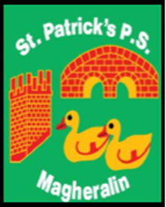

**ST. PATRICK’S PRIMARY SCHOOL**

**12 Ballymacbredan Road, Magheralin, Craigavon. BT67 OQU**

**Tel no – 028 3834 1400 Fax no – 028 3834 7376**

**Email: info@stpatricks.magheralin.ni.sch.uk**

**Principal: Mrs. M. McGrath. BA(QTS), PQHSH, DipPD.**

**‘Together we learn, together we grow, developing our future, wherever we go!’**

5th December 2023

Dear Parent

I write to inform you that our esteemed colleague and friend, Mrs Cathy Corbett, has been bereaved of her mother, Mrs Ann McVeigh (nee McCoy). May she Rest in Eternal Peace.

Requiem Mass will take place on Thursday 7th December at 11am in the Church of St John the Baptist, Portadown.

May we, as a school community, extend our sympathy to the family circle and keep the McVeigh family in our thoughts and prayers at this time.

St. Patrick pray for her.

Yours sincerely

Mrs M McGrath