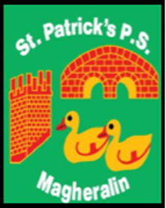

ST. PATRICK’S PRIMARY SCHOOL
12 Ballymacbredan Road, Magheralin, Craigavon. BT67 OQU
Tel no – 028 3834 1400 Fax no – 028 3834 7376
Email: info@stpatricks.magheralin.ni.sch.uk
Principal: Mrs. M. McGrath. BA(QTS), PQHSH, DipPD.
‘Together we learn, together we grow, developing our future, wherever we go!’

11th January 2024

Dear Parent/ Guardian

You will be aware from recent media coverage of ongoing industrial action by a number of Unions, that strike action is planned for next week, and possibly beyond, across various professions in the public sector.
School has been informed that NASUWT, INTO and UTU, NEU and NAHT Teaching Unions have stated their intention to call on their members to participate in strike action on
Thursday 18th November 2024. These trade Unions have confirmed that this is a FULL DAY of strike action.
Consequently, teaching staff will be unavailable for work on Thursday 18th January and school will be closed for students on Thursday 18th January.
If there is any change to this action I will be in contact as soon as I am notified. Thank you for your continued patience and understanding.
Yours sincerely,
Mrs M McGrath Principal

