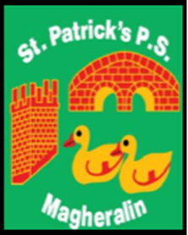

ST. PATRICK’S PRIMARY SCHOOL
12 Ballymacbredan Road, Magheralin, Craigavon. BT67 OQU
Tel no – 028 3834 1400 Fax no – 028 3834 7376
Email: info@stpatricks.magheralin.ni.sch.uk
Principal: Mrs. M. McGrath. BA(QTS), PQHSH, DipPD.
‘Together we learn, together we grow, developing our future, wherever we go!’

31st January 2024

Dear Parent,
Next week celebrates Autism (NI) Awareness week and throughout the week, we will be exploring how we are all wonderfully different and equally marvelous. On Friday 9th February, we would like all pupils to come to school dressed up as their favourite superhero. We hope to celebrate that each child is gifted, and a ‘superhero’ to us all in St Patrick’s.
We would kindly ask for a £2 donation per family which will help us purchase vital SEN resources for our school.
We look forward to seeing all our superheroes next Friday.

Yours sincerely,

_________
Miss K. Oliver
Vice Principal

