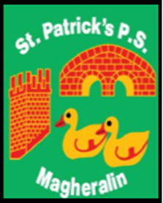

ST. PATRICK’S PRIMARY SCHOOL
12 Ballymacbredan Road, Magheralin, Craigavon. BT67 OQU
Tel no – 028 3834 1400 Fax no – 028 3834 7376
Email: info@stpatricks.magheralin.ni.sch.uk
Principal: Mrs. M. McGrath. BA(QTS), PQHSH, DipPD.
‘Together we learn, together we grow, developing our future, wherever we go!’

18th March 2020

Dear Parents

Following the announcement made today by First Minister, Arlene Foster and Deputy First Minister, Michelle O’Neill, the decision has now been made to formally close schools to pupils from Monday 24th March.

This period of closure could last until the end of this academic year.

Staff, as previously advised, will be in school until Friday to prepare work for your children. They have been preparing for this possibility and a Home Learning Pack will be sent home for each child.

We will arrange for a time to allow parents / carers to pick up this work and will inform you of the arrangements via school text.

We thank the school teaching and non-teaching staff, along with members of our Friends of group, who have been working hard to ensure that your children receive prepared work.

We ask for your continued understanding and patience at this time. We will keep you informed of any further developments via school text and our website.

We wish you and your families good health and we ask for continued prayers and support for all in our school community at this difficult time.

Yours sincerely

___________________________ ___________________________
Mrs F. Hamill Mrs M. McGrath
Chair of the Board of Governors Principal

