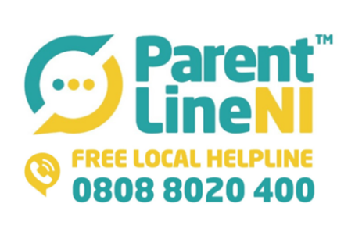

As we all navigate these unprecedented times, we at Parentline NI would like to remind you all that our Regional Parents Helpline is in full operation throughout this period. We can be contacted on freephone 0808 8020 400 to provide advice, support and guidance to parents and carers.

We are opened:
Monday- Thursday 9am-9pm
Friday 9am-5pm
Saturday 9am-1pm

You can also contact us via webchat www.ci-ni.org.uk or email parentline@ci-ni.org.uk

Please take good care of yourself and your loved ones throughout this time.

Warm Regards,

Nichola Greene
Service Manager
ParentLine NI

Children in Northern Ireland
Floor 4, 3 Glengall Street
Belfast
BT12 5AB

Tel: 028 95 622163
Mob: 07774179309
Web: www.ci-ni.org.uk

