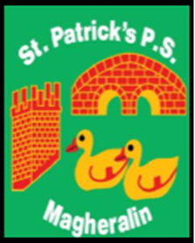

ST. PATRICK’S PRIMARY SCHOOL
12 Ballymacbredan Road, Magheralin, Craigavon. BT67 OQU
Tel no – 028 3834 1400 Fax no – 028 3834 7376
Email: info@stpatricks.magheralin.ni.sch.uk
Principal: Mrs. M. McGrath. BA(QTS), PQHSH, DipPD.
‘Together we learn, together we grow, developing our future, wherever we go!’

11th May 2020

Dear Parents
First and most importantly, I hope and pray that you and your families continue to remain safe and well. It has been a very strange and uncertain time for us all.

I would like to thank you all sincerely for keeping in touch with your child’s class teacher. The teachers in our school have been working very hard in difficult and varied circumstances to ensure that the children are gaining access to work that allows a sense of continuity and progression in their learning.

Recently each teacher asked their parents for feedback on the work that they were providing, i.e. how useful you were finding the suggested timetable, packs of work, emails, attachments etc. We were delighted with the response. The overwhelming majority of parents are very happy with how things are being delivered. This is testament to the very hard work of all of our teachers to keep in touch and provide support where it is needed.

Please remember that you as parents, are doing an incredible job to support your children at home in these very different circumstances. We understand that connectivity, IT resources, and confidence can vary in each household. Please continue to be reassured that each teacher will continue to help with any questions or concerns that you may have in relation to your child’s learning.

May we continue to keep each other in our prayers.

Mrs M. McGrath

