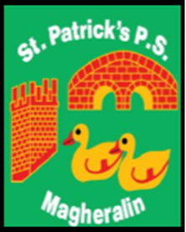

ST. PATRICK’S PRIMARY SCHOOL
12 Ballymacbredan Road, Magheralin, Craigavon. BT67 OQU
Tel no – 028 3834 1400 Fax no – 028 3834 7376
Email: info@stpatricks.magheralin.ni.sch.uk
Principal: Mrs. M. McGrath. BA(QTS), PQHSH, DipPD.
‘Together we learn, together we grow, developing our future, wherever we go!’

How to send some work on google classroom.

If you have an ipad, take a picture of the work that you did and save it into your photos.
OR
If you can type up your work on a laptop or PC, save your work into a folder.

Open your Google classroom using the ipad, laptop or PC.

In your Classroom page, you can view the work that was set. To the right hand side of that you can comment on the work (see Private comment)
Example only

Here you might write what you think of the task. Too easy?? Too Hard?? Does your teacher need to explain something?

Above this you can see ‘Your work’
You can click on + Add or create to send your work and a box will drop down with choices to add a file

Click on this and find the work that you would like to send to your teacher.

