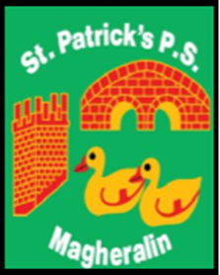

ST. PATRICK’S PRIMARY SCHOOL
12 Ballymacbredan Road, Magheralin, Craigavon. BT67 OQU
Tel no – 028 3834 1400 Fax no – 028 3834 7376
Email: info@stpatricks.magheralin.ni.sch.uk
Principal: Mrs. M. McGrath. BA(QTS), PQHSH, DipPD.
‘Together we learn, together we grow, developing our future, wherever we go!’

22nd June 2020
Dear Parents

Children’s End of Year Reports will be ready for collection at school on Friday 26th June. Due to social distancing, we have grouped our families alphabetically into times when these reports can be picked up. We will also have any books that your children had in school, ready for collection.

I would kindly ask that if your child has a school reading or library book at home that it is returned to school on this day as you collect your child’s report and school books.

All reports and books will be placed into the school assembly hall where you can collect your child’s/children’s reports and work.

Reception children’s reports can be collected with their siblings. We will post Reception class reports to those who do not have a sibling in older classes, as they will not have books/work to collect.

If you have a child in Primary 7, I ask that you come to school at their allocated time disregarding alphabetical order.

If you wish for someone else to pick up your child’s report, please email the details to their class teacher, otherwise we will post out your child’s report on Friday 26th June. We cannot post their workbooks due to the cost incurred.

Please view the table below.

Surnames beginning with the letters | Pick up time
A – E | 11am – 11:30am
F - J | 11:30am - 12noon
K - M | 12noon - 12:30pm
O - Z | 12:30pm – 1:00pm
Primary 7 | 1:00pm – 1:30pm

Kind Regards

Mrs McGrath

