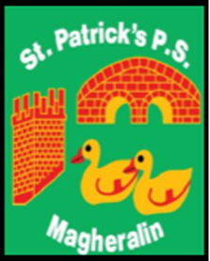

ST. PATRICK’S PRIMARY SCHOOL
12 Ballymacbredan Road, Magheralin, Craigavon. BT67 OQU
Tel no – 028 3834 1400 Fax no – 028 3834 7376
Email: info@stpatricks.magheralin.ni.sch.uk
Principal: Mrs. M. McGrath. BA(QTS), PQHSH, DipPD.
‘Together we learn, together we grow, developing our future, wherever we go!’

25th June 2020
Dear Parent

I am delighted to inform you that Fr. McConville, has been able to release the following information surrounding Sacraments for children currently in P4 and P7 in St Patrick’s Primary School;

- The Sacrament of Confirmation for our current Primary 7 children will take place on Thursday 20th August at 6pm,

- The Sacrament of The Eucharist, First Holy Communion, for our current Primary 4 children will take place on Sunday 30th August at 1:30pm.

Both Sacraments will take place in the Church of Ss Patrick and Ronan. Furthermore, due to current social distancing restrictions a maximum number of 7 members from the same family will be allowed to attend the service in the Church. Fr has informed us that each family will occupy a single pew, with separation of a pew between each family. Names will not be placed on seats; families will be guided to their seat by parish representatives.

Further guidance can be received from the parish by emailing Fr McConville to the following address mcconconor@yahoo.com . Fr McConville will also be available to receive telephone calls on a Wednesday in the parish office 028 9261 7435.

The Sacraments will not be as we would have celebrated them in previous years due to current restrictions in movement around the church and altar, to reduce contact between people. Your child’s class teacher will be in touch as soon as further details are put in place.

We look forward to finally sharing in these beautiful Sacraments with you all.

Kind Regards
Mrs M. McGrath

