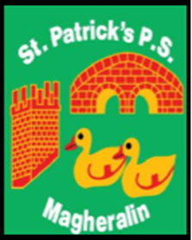

ST. PATRICK’S PRIMARY SCHOOL
12 Ballymacbredan Road, Magheralin, Craigavon. BT67 OQU
Tel no – 028 3834 1400 Fax no – 028 3834 7376
Email: info@stpatricks.magheralin.ni.sch.uk
Principal: Mrs. M. McGrath. BA(QTS), PQHSH, DipPD.
‘Together we learn, together we grow, developing our future, wherever we go!’

28th September 2020
Dear parent,

We are aiming to begin homework with your children from Monday 5th October.

Primaries 1, 2 and 3, will be provided with a folder of work on each Monday that should be completed throughout the week and returned on each Friday.
Primaries 4, 5, 6 and 7 will organise homework in the following way;
Monday
- Each Monday the children will receive spellings and associated activities that need to be completed throughout the week and returned on each Friday.
- Children in these classes will also receive tables to learn each week.
Tuesday
- Teachers will assign tasks for completion using Mathletics.
Wednesday
- Teachers will assign a ‘Newsdesk’ or ‘Google Classroom’ task, which children will access via their C2k account.
Thursday
- Children will be asked to revise spelling, tables and numeracy activities in preparation for their weekly tests.

Children will work with their teachers in class on their reading skills, using our Guided Reading Scheme and class libraries. We would also ask that you read to and with your children and encourage them to read as wide a variety of reading material outside of school. We would encourage this on a nightly basis.
A number of our Guided Reading books have not been returned to school from the period of school closure. Please check your home and if you have any of our Reading Scheme books please return them as soon as possible.

We thank you for your continued support.

Yours sincerely
Mrs McGrath

