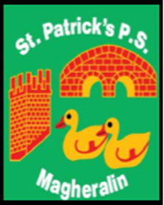

ST. PATRICK’S PRIMARY SCHOOL
12 Ballymacbredan Road, Magheralin, Craigavon. BT67 OQU
Tel no – 028 3834 1400 Fax no – 028 3834 7376
Email: info@stpatricks.magheralin.ni.sch.uk
Principal: Mrs. M. McGrath. BA(QTS), PQHSH, DipPD.
‘Together we learn, together we grow, developing our future, wherever we go!’

14th October 2020

RE: Children in receipt of Free School Meals

Dear Parent

As part of today’s announcement, the Minister of Education has stated that direct payments will be made to pupils in receipt of Free School Meals for the week commencing Monday 19th October 2020.

Yours sincerely
Mrs M McGrath
Principal

