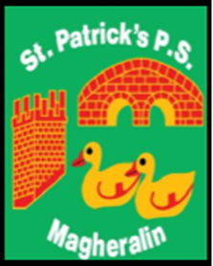

ST. PATRICK’S PRIMARY SCHOOL
12 Ballymacbredan Road, Magheralin, Craigavon. BT67 OQU
Tel no – 028 3834 1400 Fax no – 028 3834 7376
Email: info@stpatricks.magheralin.ni.sch.uk
Principal: Mrs. M. McGrath. BA(QTS), PQHSH, DipPD.
‘Together we learn, together we grow, developing our future, wherever we go!’

15th October 2020

Dear Parent/Guardian,

I wish to inform you that this morning we have been informed that a member of our school community has tested positive for Covid-19.

I have sought advice from the Public Health Agency (PHA) and EA.

EA have advised that until PHA complete their full guidance to school, as a precautionary measure, we are to send the bubble, that our school member is part of, home from school and close the classroom until further notice.
PHA will provide further advice to school today and we will be advised accordingly.

The parents of the children in the affected class have been informed this morning.

I do appreciate the concerns of parents, pupils and the wider school community and wish to reassure you that every precaution has been taken.

Ensuring the safety of pupils and staff is my absolute priority and I will continue to monitor this situation carefully and keep you informed.

Parents with any questions or concerns are welcome to contact school.

Kind regards,

Mrs M. McGrath
Principal

