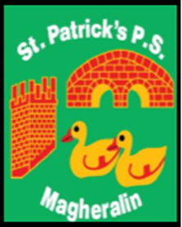

ST. PATRICK’S PRIMARY SCHOOL
12 Ballymacbredan Road, Magheralin, Craigavon. BT67 OQU
Tel no – 028 3834 1400 Fax no – 028 3834 7376
Email: info@stpatricks.magheralin.ni.sch.uk
Principal: Mrs. M. McGrath. BA(QTS), PQHSH, DipPD.
‘Together we learn, together we grow, developing our future, wherever we go!’

27th November 2020

Dear Parent

We recently asked you to participate in a Survey that would support us in our School Development Planning Process.

School Development Planning is an integral part of any school's monitoring, evaluation and development of all areas of school life. It allows us to take stock of our current position, and to plan for support and further improvement.

The Board of Governors would like to express their sincere appreciation for your contributions to the survey. All contributions are valued and we aim to use the information gathered to support the next three-year plan, which we aim to publish in the New Year.

We are delighted that the responses were largely very positive and that our staff and their continued efforts to support your children to reach their fullest potential, is valued.

There are however areas that require further focus and development. Areas surrounding Communication and our Public Presence (PR) in the community and beyond, are to be targeted.
We will reach out further to our parents (and grandparents!) asking for your support in developing these areas, as we move into this plan.

We are a small, family orientated, school, with a desire to support the children of this community, their families and the wider community as a whole. In partnership, our school can, and will remain to be, very much part of this vibrant, caring community.

'Together we learn, together we grow, developing our future, wherever we go!'

Yours sincerely

Mrs M. McGrath
Principal
Secretary to the Board of Governors

