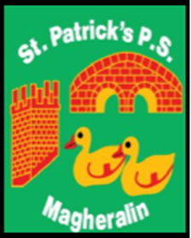

ST. PATRICK’S PRIMARY SCHOOL
12 Ballymacbredan Road, Magheralin, Craigavon. BT67 OQU
Tel no – 028 3834 1400 Fax no – 028 3834 7376
Email: info@stpatricks.magheralin.ni.sch.uk
Principal: Mrs. M. McGrath. BA(QTS), PQHSH, DipPD.
‘Together we learn, together we grow, developing our future, wherever we go!’

11th December 2020

Dear Parent

As the Christmas holidays approach, I am very aware that many of you will be looking forward to spending some much needed and valued time with family members, especially those who are elderly or vulnerable, that you may not have seen for a while. With this in mind I am also aware of growing concerns among parents, in this and in wider school communities, regarding whether or not their children should attend school next week.

Families are considering the option of protecting their family bubble, in time for Christmas by reducing as many outside of home interactions as is possible. I am conscious that a positive case of Covid 19 in the school community from this point could mean, that pupils and families are required to self-isolate over Christmas day.

After consulting with the Chair of the Board of Governors, it is agreed that any parent wishing to keep their child/ren at home from this point, to protect their family bubble, may do so.

The last school week leading up to Christmas often lends itself to finishing off specific work and or Christmas themed activities. If you would like some work for your child/ren, please contact their class teacher via their email address or for their attention via the school email address.

School will however remain open until our planned closure on 22nd December at 12 noon.

Yours sincerely

Mrs M. McGrath
Principal

