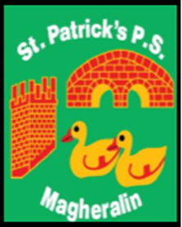

ST. PATRICK’S PRIMARY SCHOOL
12 Ballymacbredan Road, Magheralin, Craigavon. BT67 OQU
Tel no – 028 3834 1400 Fax no – 028 3834 7376
Email: info@stpatricks.magheralin.ni.sch.uk
Principal: Mrs. M. McGrath. BA(QTS), PQHSH, DipPD.
‘Together we learn, together we grow, developing our future, wherever we go!’

1st February 2021

Dear Parent

The week beginning 8th February, we aim to conduct our Parent/Teacher meetings, for the majority of our classes, via telephone call.

Primary 2/3 class however, will have their Parent/Teacher meetings on the week commencing 22nd February.

These meetings/calls will last for a period of 10 minutes.

Your child's class teacher will inform you, via Seesaw or Google Classroom, of a suggested Day and Time of when the call will take place. Upon receipt of this information please reply to your child's teacher to state whether this day/time is acceptable and with the telephone number that you would like the call to be made to.

Calls will take place on the days that your child's class teacher will be on rota in school to support supervision duties. Teachers will be able to discuss your child's progress in class up to Christmas and offer any advice, support and guidance for this period of remote learning.

Please note that on the days that your child's class teacher is involved in Parent/Teacher calls, they will not communicate with the children on their online learning platform. Work will be provided on these days however, for your child to continue with. Any relevant answers for the children’s work in classes P4 to P7, will be uploaded for you to mark with your child on these days.

Yours sincerely

Mrs. M. McGrath
Principal

