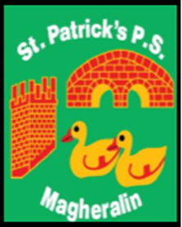

ST. PATRICK’S PRIMARY SCHOOL
12 Ballymacbredan Road, Magheralin, Craigavon. BT67 OQU
Tel no – 028 3834 1400 Fax no – 028 3834 7376
Email: info@stpatricks.magheralin.ni.sch.uk
Principal: Mrs. M. McGrath. BA(QTS), PQHSH, DipPD.
‘Together we learn, together we grow, developing our future, wherever we go!’

10th March 2021

Dear Parent
Below you will find an update on when the Sacraments will take place for children in Primary 4 and Primary 7. You will see a change from previously advised dates. Please note that all dates are still subject to change, depending on NI Executive and DENI directives. We will inform you as soon as we are advised of any changes.

Primary 4
First Confession – Tuesday 11th May at 7pm
Holy Communion – Sunday 6th June at 1pm

Primary 7
Service of Light – Saturday 24th April at 6pm
Confirmation – Thursday 6th May at 6pm

Yours sincerely
Mrs M McGrath
Principal

