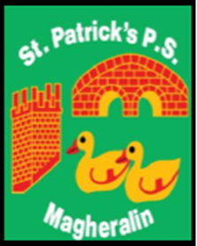

ST. PATRICK’S PRIMARY SCHOOL
12 Ballymacbredan Road, Magheralin, Craigavon. BT67 OQU
Tel no – 028 3834 1400 Fax no – 028 3834 7376
Email: info@stpatricks.magheralin.ni.sch.uk
Principal: Mrs. M. McGrath. BA(QTS), PQHSH, DipPD.
‘Together we learn, together we grow, developing our future, wherever we go!’

25th June 2018

Dear Parent

Please find below the holiday list for next year, 2018/2019.

- School Dates for 2018/2019

- Monday 3rd September – School re-opens for the new school year!
- Monday 8th October – School closed for Staff Development
- Monday 29th October to Friday 2nd November. (Dates inclusive) School
closed – Halloween break and Staff Development
- Monday 24th December – Wednesday 2nd January 2019 - (Dates
inclusive) School Closed Christmas break and Staff Development
- Monday 18th – Friday 22nd February - School Closed - Half Term
- Monday 18th and Tuesday 19th March - School Closed - St Patrick’s Day
and Staff Development
- Friday 19th April – Friday 26th April - School Closed- Easter break
- May 6th - School closed - Bank Holiday
- Monday 27th May and Tuesday 28th May – School closed – Bank Holiday
and Staff Development
- June 28th - School closes for the academic year.

Yours sincerely

Mrs. McGrath
Principal

