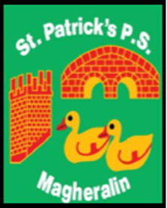

ST. PATRICK’S PRIMARY SCHOOL
12 Ballymacbredan Road, Magheralin, Craigavon. BT67 OQU
Tel no – 028 3834 1400 Fax no – 028 3834 7376
Email: info@stpatricks.magheralin.ni.sch.uk
Principal: Mrs. M. McGrath. BA(QTS), PQHSH, DipPD.
‘Together we learn, together we grow, developing our future, wherever we go!’

23rd March 2021

Dear Parent

Primary 3 – Summer Term Finish time

As previously advised, Primary 3 children will remain in school until 3pm Monday – Thursday for the Summer term.

Please note this is with effect from Monday 12th April 2021.

Please ensure that anyone involved in your child’s care/collection arrangement, is aware of this change of time.

We will send a reminder via text.

Yours sincerely

Mrs McGrath
Principal

