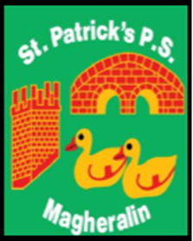

ST. PATRICK’S PRIMARY SCHOOL
12 Ballymacbredan Road, Magheralin, Craigavon. BT67 OQU
Tel no – 028 3834 1400 Fax no – 028 3834 7376
Email: info@stpatricks.magheralin.ni.sch.uk
Principal: Mrs. M. McGrath. BA(QTS), PQHSH, DipPD.
‘Together we learn, together we grow, developing our future, wherever we go!’

29th June 2018

Dear Parents

Arrangements for Breakfast Club, Drop Off Club and Afterschool Club will continue into next year. Please however, notice a small change in costs from September 2018.
We are unfortunately unable to extend the hours of our After School Club past 4:30pm, on a Friday, due to lack of demand and required staffing levels. Monday to Thursdays will remain open until 5pm. This is something that we will reconsider on an annual basis.

Breakfast Club - 8am – Remains at a cost of £2.50 per child per morning

Drop Off Club – 8:30am - Remains at a cost of £1:20 per child per day

Afterschool Club – Available from 2:00pm until 5:00pm - £3:50 per child per hour.
Please note the small change to the cost of the afterschool per hour. This club is currently running at a deficit. We aim only to cover costs with this increase to ensure that this club can continue.

Yours sincerely
Mrs McGrath
Principal

