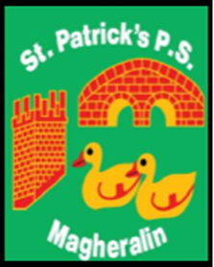

ST. PATRICK’S PRIMARY SCHOOL
12 Ballymacbredan Road, Magheralin, Craigavon. BT67 OQU
Tel no – 028 3834 1400 Fax no – 028 3834 7376
Email: info@stpatricks.magheralin.ni.sch.uk
Principal: Mrs. M. McGrath. BA(QTS), PQHSH, DipPD.
‘Together we learn, together we grow, developing our future, wherever we go!’

29th June 2021

Dear Parent/Guardian

I write to inform you that Mrs Canavan has been the successful candidate in a temporary post with the Education Authority. Her new role will be as an Assistant Advisory Officer for Primary Behaviour Support and Provision.
For this new role Mrs Canavan will be seconded to the EA for a period of one year. Therefore, she will not be present in school to teach her P2/3 class for the 2021/2022 school year.
I take this opportunity to wish Mrs Canavan every success in her post and I know that she will be a great asset to this team.
The process will now be set in place to secure a teacher for the Primary 2/3 class for September and you will be informed of the outcome as soon as it is available.

Kind Regards
Mrs M McGrath
Principal

