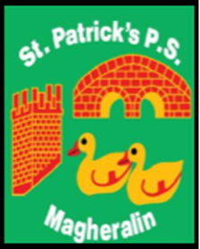

ST. PATRICK’S PRIMARY SCHOOL
12 Ballymacbredan Road, Magheralin, Craigavon. BT67 OQU
Tel no – 028 3834 1400 Fax no – 028 3834 7376
Email: info@stpatricks.magheralin.ni.sch.uk
Principal: Mrs. M. McGrath. BA(QTS), PQHSH, DipPD.
‘Together we learn, together we grow, developing our future, wherever we go!’

3rd August 2021

Dear Parent/Guardian

I hope that you and your families have been able to enjoy some relaxing time together and have been able to make the most of the lovely periods of weather that we have been having so far.

I would like to confirm that Miss Natasha Caldwell will be joining the team in St. Patrick’s, as she will be teaching in our P2/3 class from September. Miss Caldwell has previously taught in our P2/3 class and is looking forward to working with the children.

Primary 2/3 will finish at 2pm each day. However, after the Easter break the Primary 3 class will finish at 3pm Monday to Thursday and at 2pm each Friday.

I hope that you all will continue to enjoy the holiday period with your families.

Yours sincerely

Mrs M. McGrath
Principal

