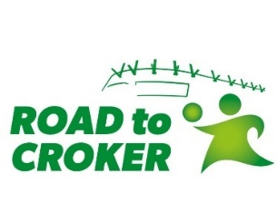
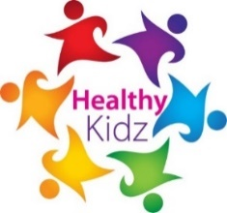

September 2021
Healthy Kidz After School Clubs and In-School Provision
Dear Parent/Guardian,
This new school year we are delighted that Healthy Kidz will again be in your school. Healthy Kidz is a schools coaching programme currently being delivered in over 130 schools. Our aim is to get every child Active, Fit and Healthy through a multi-strand approach, led by a Physical Activity leader, dedicated to your school.
St. Patrick’s Primary School has committed to the following level of coaching in an effort to improve the health and well-being of each child participating: In School and After School Programmes begin on Tuesday 28th September 2021 for 10 weeks.
School Coaching Time: Reception to Primary 3 weekly PE sessions on Tuesdays during school time.
Tuesdays After School Club – Road to Croker Gaelic Games:
2 – 3pm for P1 – P3
3 – 4pm for P4 – P7
Thursdays After School Club – Sports Club
2 – 3pm Sports Club for P1 – P3
3 – 4pm Sports Club for P4 – P7
After School sessions will cost £30 per child for each after school club, and this is to be paid up front to Healthy Kidz to ensure a place (places are limited); sessions will run for 10 weeks. In order to book your child’s place please follow the link https://healthy-kidz.com/afterschools to book and pay for a place for your child in the Healthy Kidz After School Clubs.
Yours sincerely
Healthy Kidz

