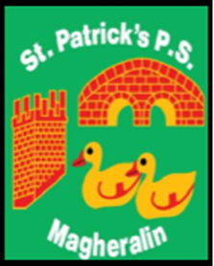

ST. PATRICK’S PRIMARY SCHOOL
12 Ballymacbredan Road, Magheralin, Craigavon. BT67 OQU
Tel no – 028 3834 1400 Fax no – 028 3834 7376
Email: info@stpatricks.magheralin.ni.sch.uk
Principal: Mrs. M. McGrath. BA(QTS), PQHSH, DipPD.
‘Together we learn, together we grow, developing our future, wherever we go!’

9th December 2021

Dear Parent

Christmas Dinner Day – Friday 17th December

Due to covid restrictions, this year’s Christmas dinner will take the form of a Happy Meal style meal of chicken nuggets, cocktail sausages and chips, rather than the traditional Christmas dinner usually offered. Meals will be delivered to the classrooms in individual disposable boxes/bags.

It will take place on Friday 17th December. If you wish your child to avail of this Christmas party meal, this can be booked and paid for on the Eduspot school money system.

As with previous years, we plan to have our Christmas Jumper day on the Christmas Party Meal day, to add to the fun atmosphere! We ask for donations of £1 per child towards school funds. This can also be paid on Eduspot!

Yours sincerely

Mrs M. McGrath
Principal

