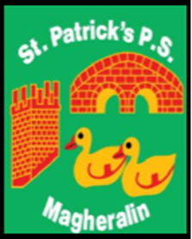

ST. PATRICK’S PRIMARY SCHOOL
12 Ballymacbredan Road, Magheralin, Craigavon. BT67 OQU
Tel no – 028 3834 1400 Fax no – 028 3834 7376
Email: info@stpatricks.magheralin.ni.sch.uk
Principal: Mrs. M. McGrath. BA(QTS), PQHSH, DipPD.
‘Together we learn, together we grow, developing our future, wherever we go!’

27th January 2022

Dear Parents

As I have previously informed you, as a direct result of the Covid-19 pandemic, there are unprecedented pressures on both teaching and non-teaching staff within schools across the entire education system in Northern Ireland.

As a result, there is a significant shortage of available substitute teachers across all sectors and many schools are finding that securing substitute teachers for their classes has become impossible.

Due to a current staff shortage in the Primary 2/3 class I write to inform you that all pupils in Primary 2/3 are asked not to attend school tomorrow, Friday 28th January.

I understand that this is not ideal, and please be fully assured that this decision has been made as a last resort option.

Work will be posted onto Seesaw for the children to complete tomorrow.

To allow us all to remain at school for as many days as is possible we ask all parents to ensure that your child is kept off school should they show any of the following symptoms;

- a high temperature, or;

- a new, continuous cough – this means coughing a lot for more than one hour, or three or more coughing episodes in 24 hours (if you usually have a cough this could be worse than usual), or;

-anosmia – the loss or change in your normal sense of smell (it can affect your sense of taste).

Thank you in advance for your support and understanding.

Yours sincerely

Mrs M. McGrath
Principal

