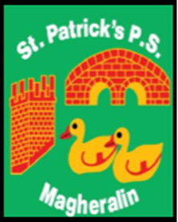

ST. PATRICK’S PRIMARY SCHOOL
12 Ballymacbredan Road, Magheralin, Craigavon. BT67 OQU
Tel no – 028 3834 1400 Fax no – 028 3834 7376
Email: info@stpatricks.magheralin.ni.sch.uk
Principal: Mrs. M. McGrath. BA(QTS), PQHSH, DipPD.
‘Together we learn, together we grow, developing our future, wherever we go!’

28th February 2022

Dear Parent / Guardian

I write to inform you that due her success in gaining a permanent position, as an Assistant Advisory Officer for Primary Behaviour Support and Provisions within the Education Authority, Mrs Aine Canavan is to permanently leave her teaching post at St Patrick's.

Mrs Canavan has worked with us at St Patrick’s for 10 years and was a valued member of staff. She will be missed by our school community. I am sure that you will join us in wishing her every success in her new post.

Yours sincerely

Mrs M. McGrath
Principal

