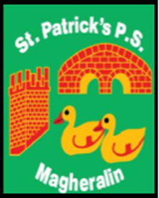

ST. PATRICK’S PRIMARY SCHOOL
12 Ballymacbredan Road, Magheralin, Craigavon. BT67 OQU
Tel no – 028 3834 1400 Fax no – 028 3834 7376
Email: info@stpatricks.magheralin.ni.sch.uk
Principal: Mrs. M. McGrath. BA(QTS), PQHSH, DipPD.
‘Together we learn, together we grow, developing our future, wherever we go!’

25th March 2022

Dear Parent,

Please be advised that from Monday 28th March, due to Health and safety consideration, the school gates will be closed throughout each day.

The gates will be closed from 9:30am each morning. School staff will open and close them again 10 minutes before and after Reception class, 2pm and 3pm collection times.

We respectfully ask that if you are to enter or exit the school grounds during the periods of gate closure that you close the gates behind you each time.

We sincerely thank you in advance of your understanding and cooperation.

Mrs. McGrath
Principal

